

|  |  |  |  |  |  |  |  |  |
| --- | --- | --- | --- | --- | --- | --- | --- | --- |
|  | | | | | | | | |
|  | | Problem Statement andDesign Thinking | | | | |  | |
|  |  | | | | | | |  |
|  | | | |  |  | | | |
|  | | | | ELECTRICITY PRICES PREDICTION |  | | | |
|  | | | |  |  | | | |
|  | | |  | | |  | | |



|  |  |  |  |  |  |  |  |  |  |  |  |  |  |  |
| --- | --- | --- | --- | --- | --- | --- | --- | --- | --- | --- | --- | --- | --- | --- |
|  | |  | | |  | |  | | | | |  | | |
|  | | INSTRUCTIONS | | | | | | | | | |  | | |
|  | |  | | |  | |  | | | | |  | | |
|  | |  | |  | | | | |  | | |  | | |
|  | |  |  | In the era of Digital Transformation, every application runs on power which is nothing but electricity. So, a proper mechanism is required to analyze the capacity of electricity used in our day-to-day life for domestic as well as industrial purposes. Prediction of price of electricity not only provides you information about how much you need to pay but also provide information about how much capacity you are using how much is required and related information. As a proper analysis and prediction of electricity is required, this research work has developed a model to predict electricity using Data Science Algorithm. Electricity price prediction depends on different factors like national wind, wind production etc., due to which it is a challenging task. This model help in predicting amount of electricity consumed and provided using historical dataset and make it easier to user for calculating the electricity bill and easy to check there past statement. This method also contain weather report for wind speed which varies the energy consumption. The aim is  to reduce the manual work and to make the process efficient as well as accurate . | | | | |  |  | |  | | |
|  | | | | | | |
|  | PROBLEM STATEMENT | | | | | | | | | | | |  |
|  | |  | | | |  | |  | | |  | | |
|  |  | | | | | | | | | | | |  |

* There are a number of issues that arise due to manual billing which includes incorrect computation/calculations, improper meter reading, delayed bill delivery, rounding off issues etc. Another major drawback of manual billing is the storage of the bills and maintaining a history of electricity consumption.
* The user is not bound to pay excesses amount of money; user must pay according to their requirement. It can reduce problems associated with billing consumer living in isolated areas and reduce deployment of manpower for taking meter readings.
* Real time and Accurate billing information

OBJECTIVE:

* To detect the energy meter tampering and to notify the concerned authority.
* To reduce the man power required for meter reading/billing system.
* To send the notification to the customers about the amount of power consumption and tariff through mobile application.

TECHNOLOGY STACK:

* **PLATFORM:** Visual Studio Code for development operations like debugging, task running, and version control.
* **CLOUD HOSTING:** AWS(Amazon Web Services) for cloud computing.
* **FRONT END:** Angular JS for an interactive user interface
* **BACK END:** Python and Node JS for an interactive with Server side development

METHODOLOGY:

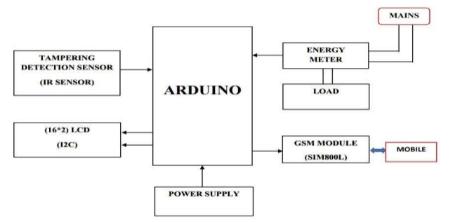

* + The electricity is consumed, the electricity bill is generated, the generated bill can be seen in our smart phone as well as on our LCD.
  + The system consists of the bulb, where the bulb is used as load.
  + IR sensor, GSM module, energy meter and power supply are connected to the Arduino pin.
  + The integration of the Arduino and GSM provide the meter reading system with some automatic functions that are predefined.
  + GSM module transmits the data like consumed energy in Kwh, generated bill, security services.
  + The bill will be generated for total count of load.

CONCLUSION:

The automation of billing system eliminates human involvement hence more accurate and reliable. The implementation of time of-day billing can control the usage of electricity on consumer side to avoid wastage of power which helps in reduction of energy generation costs. The introduced Prepaid Billing System minimizes the Electricity theft in a cost-effective manner. Automation of meter reading also gives the information of total load used in a house on request at any time as well as to make consumers to keep track of energy usage.